Cryptocurrency Price Tracker –Project Report
Author: Vemulapalli Sravya(Team 1),
Project Type: Individual Project

EXECUTIVE SUMMARY:
The Cryptocurrency Price Tracker project demonstrates the implementation of an automated real-time cryptocurrency data extraction system using Python and Selenium WebDriver. The tool scrapes live market data from CoinMarketCap and presents it in a structured tabular format in the console, with optional data export to CSV files for historical analysis. This system eliminates the dependency on manual checking of cryptocurrency prices by providing an automated and reliable mechanism for monitoring price movements, trends, and market capitalization. The application supports headless browser automation and filtering mechanisms for customized market analysis.

PROJECT OVERVIEW:
Objective:
To build an automated tool that collects real-time cryptocurrency market data from CoinMarketCap and stores it in a structured format for analysis and decision-making.
Scope:
- Real-time cryptocurrency data scraping
- Top 10 coin monitoring
- Price, market cap, and 24-hour change extraction
- CSV-based historical logging
- Filtering by price and percentage change
- Headless browser support
Key Features:
- Live Scraping – Fetches dynamic market data
- Headless Mode – Runs in background without UI
- Data Export – Stores pricing data in CSV format
- Filtering – Filter coins by price and 24h change
- Top Gainers & Losers – Identifies market movements
- Timestamp Logging – Enables trend analysis over time

TECHNICAL IMPLEMENTATION:
Architecture:
The system follows an automated scraping pipeline:
- User Input Collection (headless / filters / coin limit)
- WebDriver Initialization
- Page Rendering via Selenium
- DOM Parsing and Data Extraction
- Data Processing using Pandas
- CSV Export and Console Display
- Termination of WebDriver Session
Technology Stack:
- Python 3.11 - Core programming language
- Selenium - Browser automation and scraping
- WebDriver Manager -Automatic driver handling
- Pandas - Data manipulation & CSV export
- CSV - Persistent storage
- Chrome WebDriver - Rendering JavaScript-based data
Performance Metrices:
- Load Time: 5–10 seconds
- Data Capture Rate: 10 coins per execution
- Reliability: High (JS-rendered content supported)
- Storage Format: CSV with timestamps

SOURCE CODE IMPLEMENTATION (Screenshot):
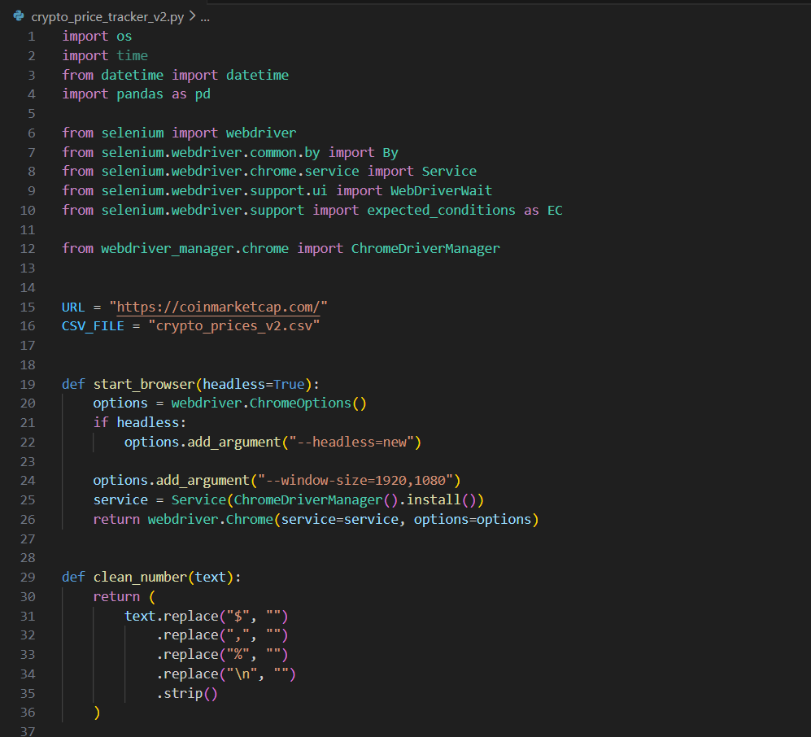
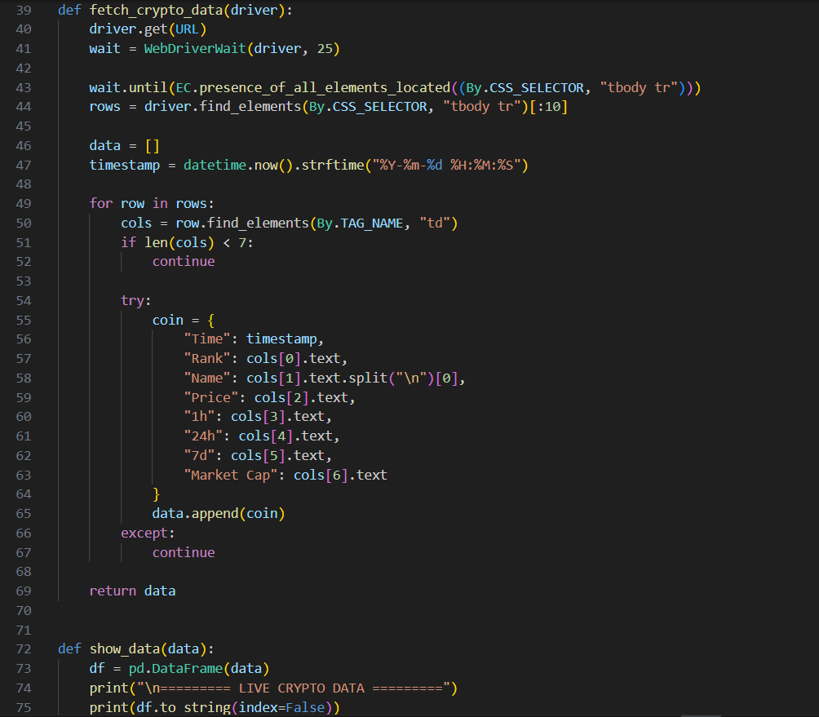
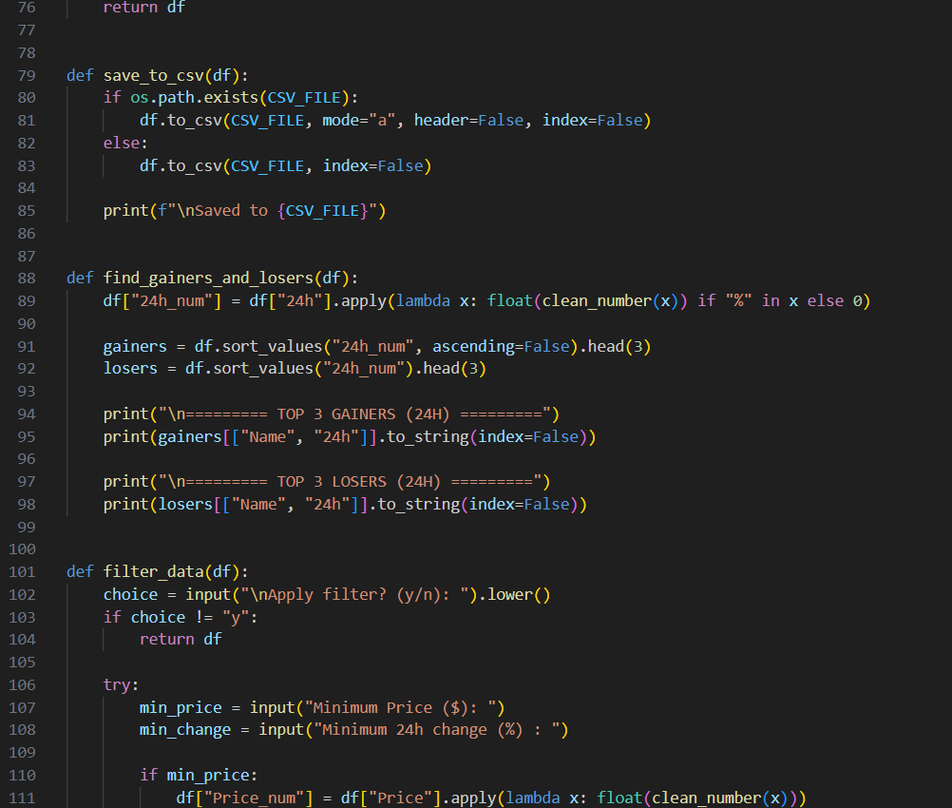
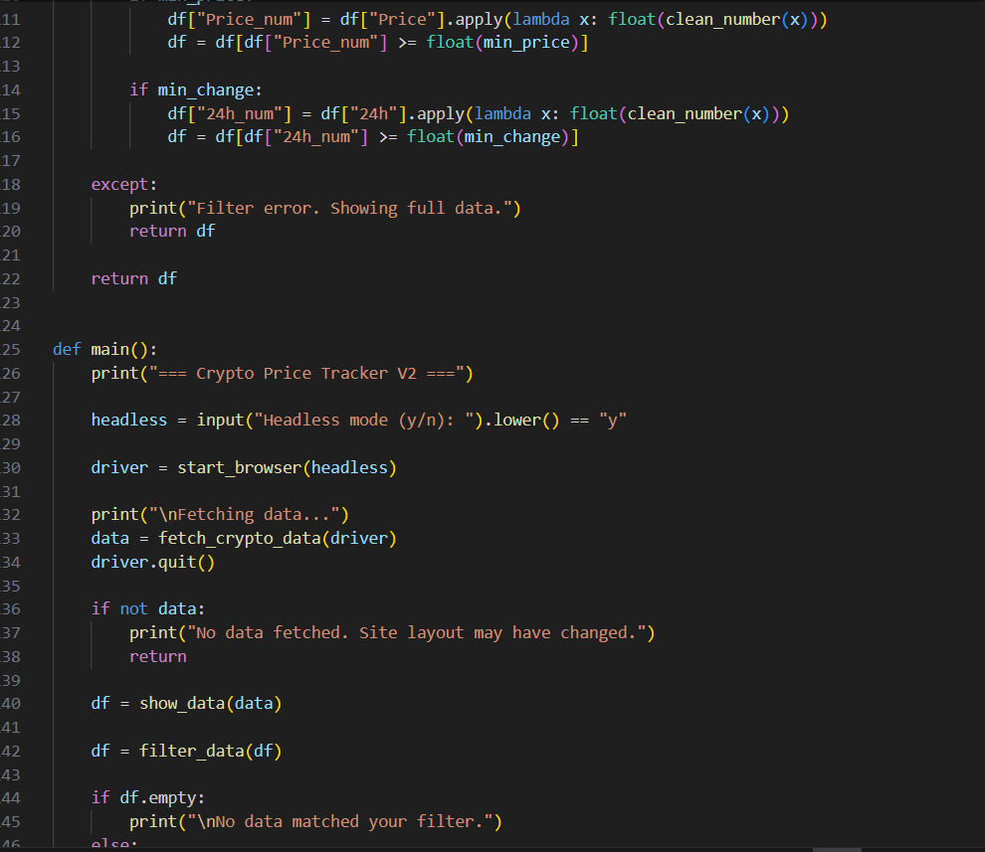
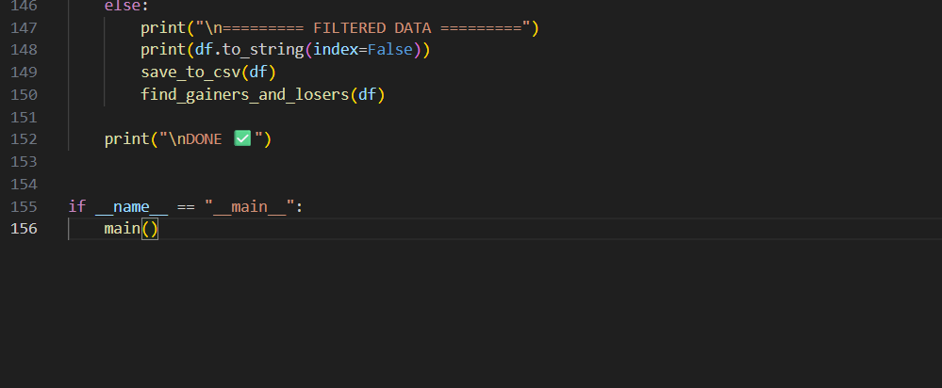

Extracted Job Result In Excel:
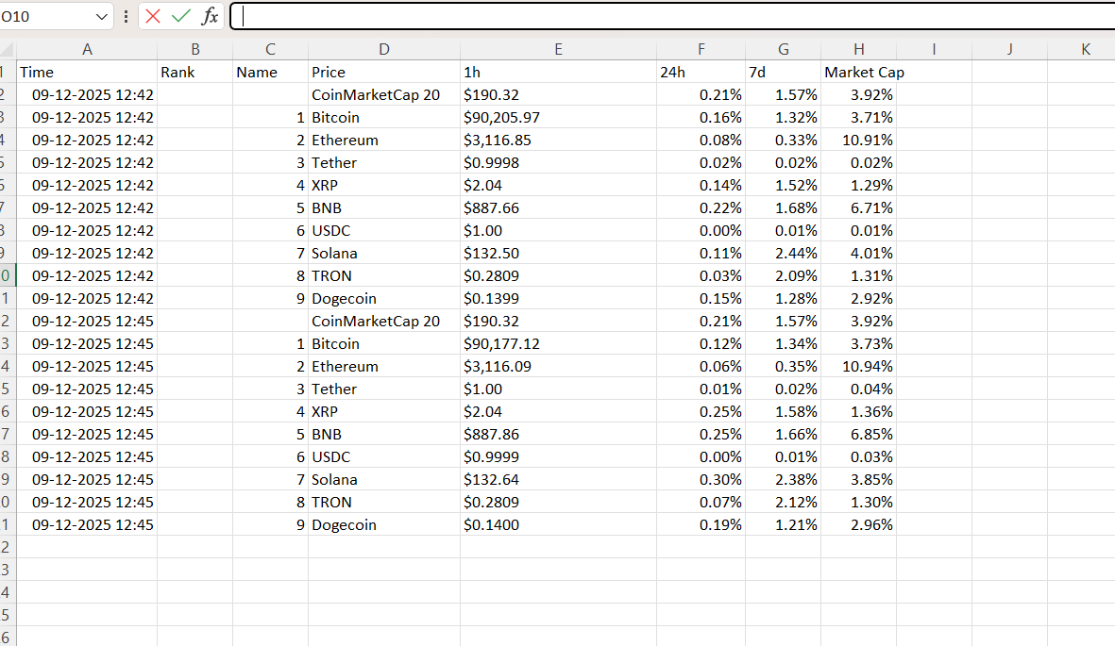
KEY ACHIEVEMENTS:
Technical Accomplishments:
- Successful Selenium integration with CoinMarketCap
- Dynamic JavaScript scraping capability
- Effective browser automation in both UI and headless mode
- Accurate historical logging using CSV
- Automatic ChromeDriver management
- Advanced filter logic for price analysis
Process Automation Benefits:
- Saves manual effort
- Provides accurate real-time data
- Enables offline data analysis
- Reusable for data science and visualization projects

LIMITATIONS AND CONSTRAINTS:
Current Limitations:
- Limited to CoinMarketCap only
- No real-time dashboard
- Internet required
- Static file export only (CSV)
Resource Constraints:
- Dependent on website layout
- Scraping speed dependent on network
- No cloud database support

PROJECT IMPACT AND VALUE:
- Immediate Benefits:
- Reduces effort in tracking crypto prices
- Automates repetitive market checking
- Allows structured data retention
- Long-Term Potential:
- Dashboard integration
- Machine learning trend prediction
- Portfolio analytics
- Alert systems
- Database storage

CONCLUSION:
The Cryptocurrency Price Tracker project successfully demonstrates real-time data automation using Selenium and Python. It provides an efficient tool for cryptocurrency monitoring while enabling historical data analysis through CSV logging. The project showcases strong fundamentals in automation, scraping, exception handling, and data processing. With further enhancements such as dashboards and AI-based predictions, this tool can be expanded into a full-fledged crypto analytics platform.

